

Vrdnik, Serbia, 16.09-19.09.2026.
Please return the completed form to the reception of the ethno village Vrdnička kula - bungalows

The reservation is accepted only in this form

Date: _____________________________________________

Name:

E - mail:

Arrival date:

Departure date:

Ethno village Vrdnička kula - bungalows 16.09-19.09.2026.

Bed and breakfast:
Bungalow for one person: 17.500,00 RSD per night
Bungalow for two people: 8.750,00 RSD per person per night
Bungalow for three people: 6.830,00 RSD per person per night
Bungalow for four people: 5.875,00 RSD per person per night

City tax: 110,00 RSD per person per night

The package includes:
*Check in at 2:00 PM, check out at 11:00 AM
*Accommodation based on the selected service
*Water world of the Movenpick Resort & Spa Fruške Terme hotel
*Sauna world of the Movenpick Resort & Spa Fruške Terme hotel
*Non-alcoholic minibar + coffee machine in the room
*Parking

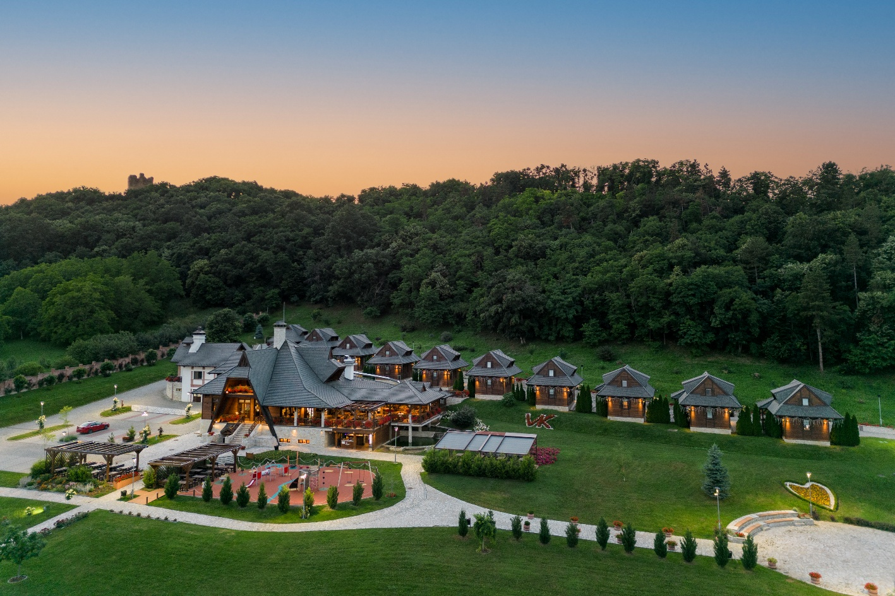

Accommodation type according to availability:
Please mark the accommodation type
1. Bungalow for one person
2. Bungalow for two people
3. Bungalow for three people
4. Bungalow for four people

A 100% advance payment is required to confirm the reservation.
If you wish to make the payment through the company account, it is necessary to provide the company's ID details.

Accommodation reservations can be made no later than 01.09.2026., subject to availability.
For reservations made after this date, the hotel does not guarantee the price or availability.

Cancelation policy:
50% of the paid ammount is retained by the hotel if cancellation occurs 14 days before arrival.
100% of the paid ammount is retained by the hotel if cancellation occurs 7 days before arrival.

We wish you a pleasant stay!

Address for reservations: info@frusketerme.com

Phone:
022/21-55-260
063/495-477

